Android Context Menu Example

Let's see the simple example of context menu in android.

**activity_main.xml**

Drag one listview from the pallete, now the xml file will look like this:

*File: activity_main.xml*

1. **<RelativeLayout** xmlns:android="http://schemas.android.com/apk/res/android"
2. xmlns:tools="http://schemas.android.com/tools"
3. android:layout_width="match_parent"
4. android:layout_height="match_parent"
5. android:paddingBottom="@dimen/activity_vertical_margin"
6. android:paddingLeft="@dimen/activity_horizontal_margin"
7. android:paddingRight="@dimen/activity_horizontal_margin"
8. android:paddingTop="@dimen/activity_vertical_margin"
9. tools:context=".MainActivity" **>**
11. **<ListView**
12. android:id="@+id/listView1"
13. android:layout_width="match_parent"
14. android:layout_height="wrap_content"
15. android:layout_alignParentLeft="true"
16. android:layout_alignParentTop="true"
17. android:layout_marginLeft="66dp"
18. android:layout_marginTop="53dp" **>**
19. **</ListView>**
21. **</RelativeLayout>**

Activity class

Let's write the code to display the context menu on press of the listview.

*File: MainActivity.java*

1. **package** com.javatpoint.contextmenu;
2. **import** android.os.Bundle;
3. **import** android.app.Activity;
4. **import** android.view.ContextMenu;
5. **import** android.view.ContextMenu.ContextMenuInfo;
6. **import** android.view.Menu;
7. **import** android.view.MenuItem;
8. **import** android.view.View;
9. **import** android.widget.AdapterView;
10. **import** android.widget.ArrayAdapter;
11. **import** android.widget.ListView;
12. **import** android.widget.Toast;
13. **public** **class** MainActivity **extends** Activity {
14. ListView listView1;
15. String contacts[]={"Ajay","Sachin","Sumit","Tarun","Yogesh"};
16. @Override
17. **protected** **void** onCreate(Bundle savedInstanceState) {
18. **super**.onCreate(savedInstanceState);
19. setContentView(R.layout.activity_main);
20. listView1=(ListView)findViewById(R.id.listView1);
21. ArrayAdapter<String> adapter=**new** ArrayAdapter<String>(**this**,android.R.layout.simple_list_item_1,contacts);
22. listView1.setAdapter(adapter);
23. // Register the ListView  for Context menu
24. registerForContextMenu(listView1);
25. }
26. @Override
27. **public** **void** onCreateContextMenu(ContextMenu menu, View v, ContextMenuInfo menuInfo)
28. {
29. **super**.onCreateContextMenu(menu, v, menuInfo);
30. menu.setHeaderTitle("Select The Action");
31. menu.add(0, v.getId(), 0, "Call");//groupId, itemId, order, title
32. menu.add(0, v.getId(), 0, "SMS");
33. }
34. @Override
35. **public** **boolean** onContextItemSelected(MenuItem item){
36. **if**(item.getTitle()=="Call"){
37. Toast.makeText(getApplicationContext(),"calling code",Toast.LENGTH_LONG).show();
38. }
39. **else** **if**(item.getTitle()=="SMS"){
40. Toast.makeText(getApplicationContext(),"sending sms code",Toast.LENGTH_LONG).show();
41. }**else**{
42. **return** **false**;
43. }
44. **return** **true**;
45. }
46. }

[download this android example](https://www.javatpoint.com/src/android/ContextMenu.zip)

Output:

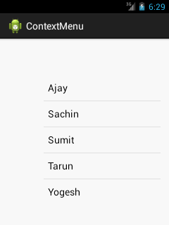

Output after long press on the listview.

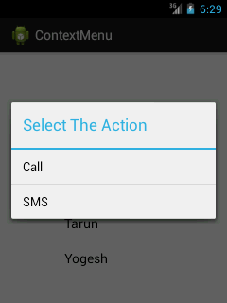

Output after clicking on the context menu.

